Creating my First Git Branch.
On VS Code Terminal  Run:  git switch -c git-practice  git switch -c git-practice  │ │ │ │  │ │ │ └── Name of our new branch  │ │ │  │ │ └───────── -c = CREATE a new branch  │ │  │ └──────────────── Switch branches  │  └───────────────────── Run Git  - VS code will show you which Git Branch you’re currently working on.  *Notice ‘git-practice’ | 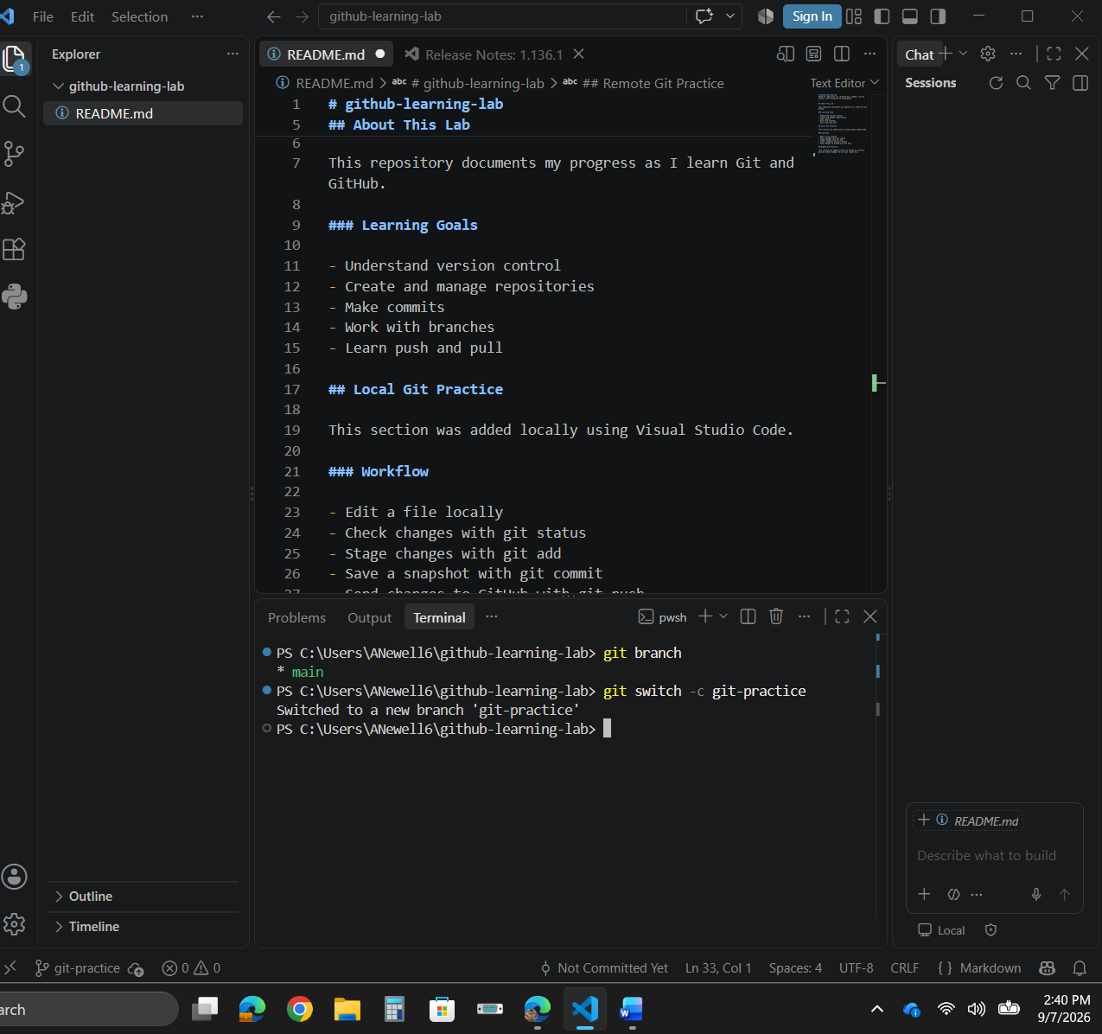
Next confirm:  Run: git branch  * git-practice  │ │  │ └── New branch we just created  │  └───────── * = HEAD/current branch  main  │  └──────── Original main branch still exists  * HEAD is Git's pointer to the commit currently checked out. When attached to a branch, it effectively indicates the branch you are currently working on. | 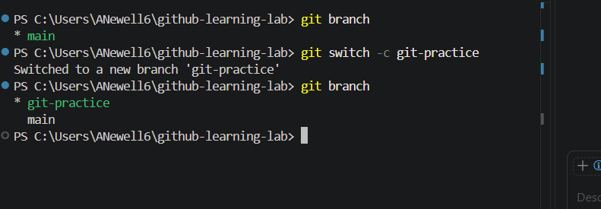  GitHub Profile  AnewG-963  │  ▼  Repository  github-learning-lab  │  ├── main  │  └── git-practice ← HEAD  ↑  YOU ARE HERE
You can switch to main anytime by running:  git switch main.  Then back to git-practice run:  git switch git-practice | 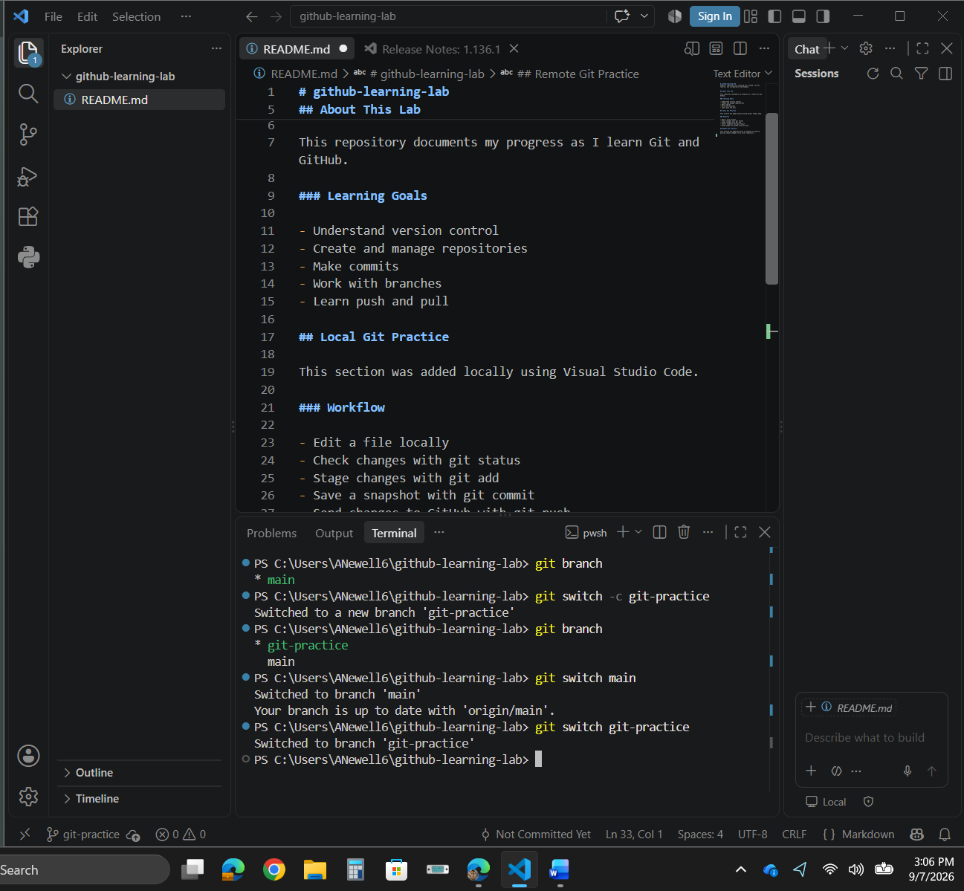
 | Proving why branches are useful.
Copy and paste:  ## Branch Practice  This section was created on the git-practice branch.  The purpose of this branch is to practice making changes without modifying the main branch. | 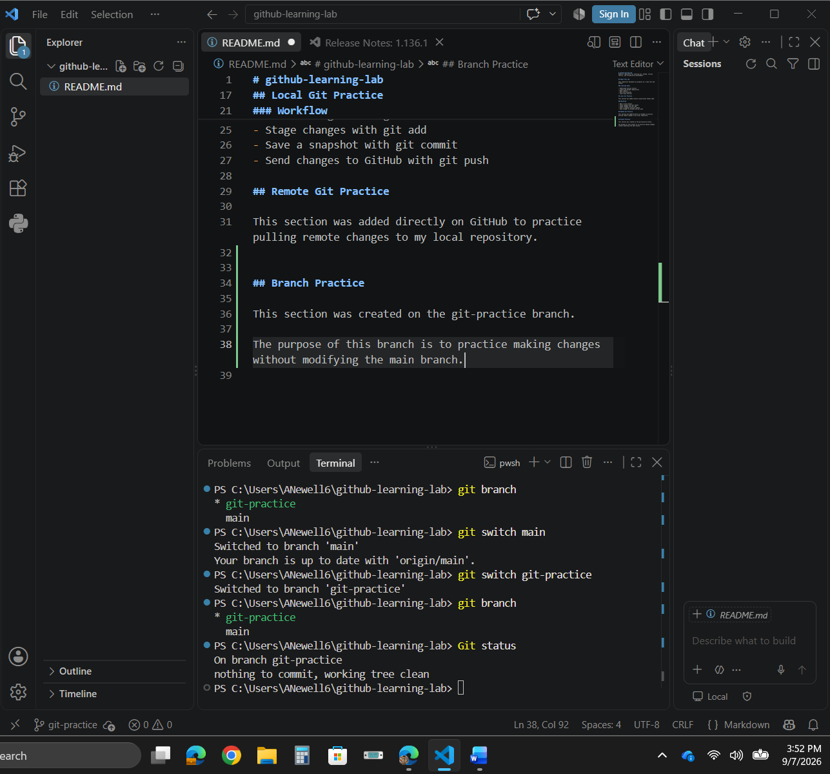
Ask Git what changed:  Run:  git status  *You will see in the terminal that README.md has been modified, with the new Markdown content that we had just added. | 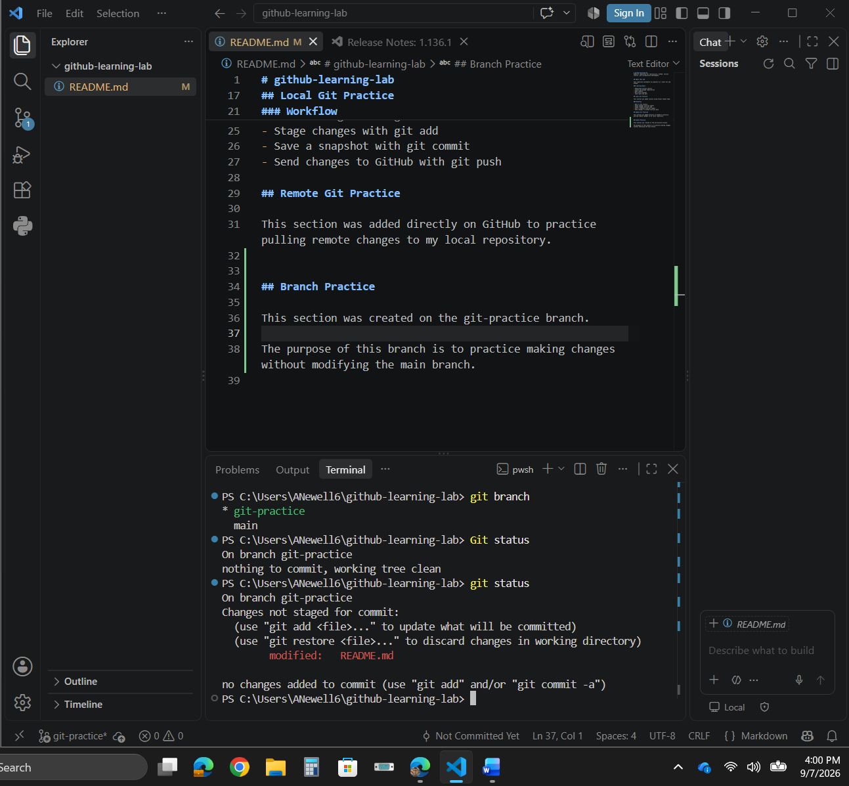
On branch git-practice  Changes not staged for commit:  modified: README.md  That means Git sees the change, but it is not yet selected for the next commit. | 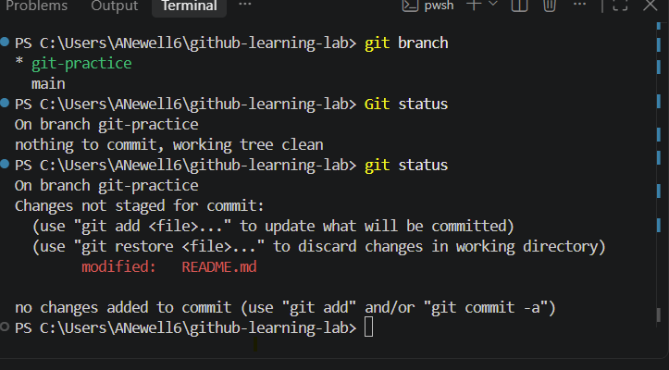
Run:  git add README.md  git add README.md  │ │ │  │ │ └── The file we want to stage  │ │  │ └────────── Put its current changes into the staging area  │  └────────────── Run Git | 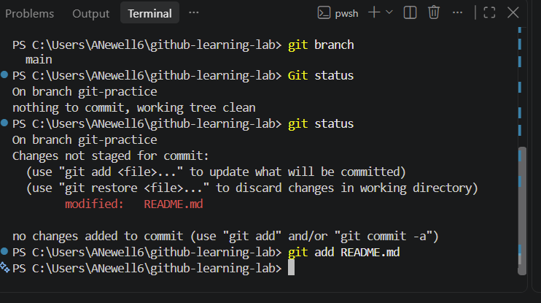
Run:  git status | 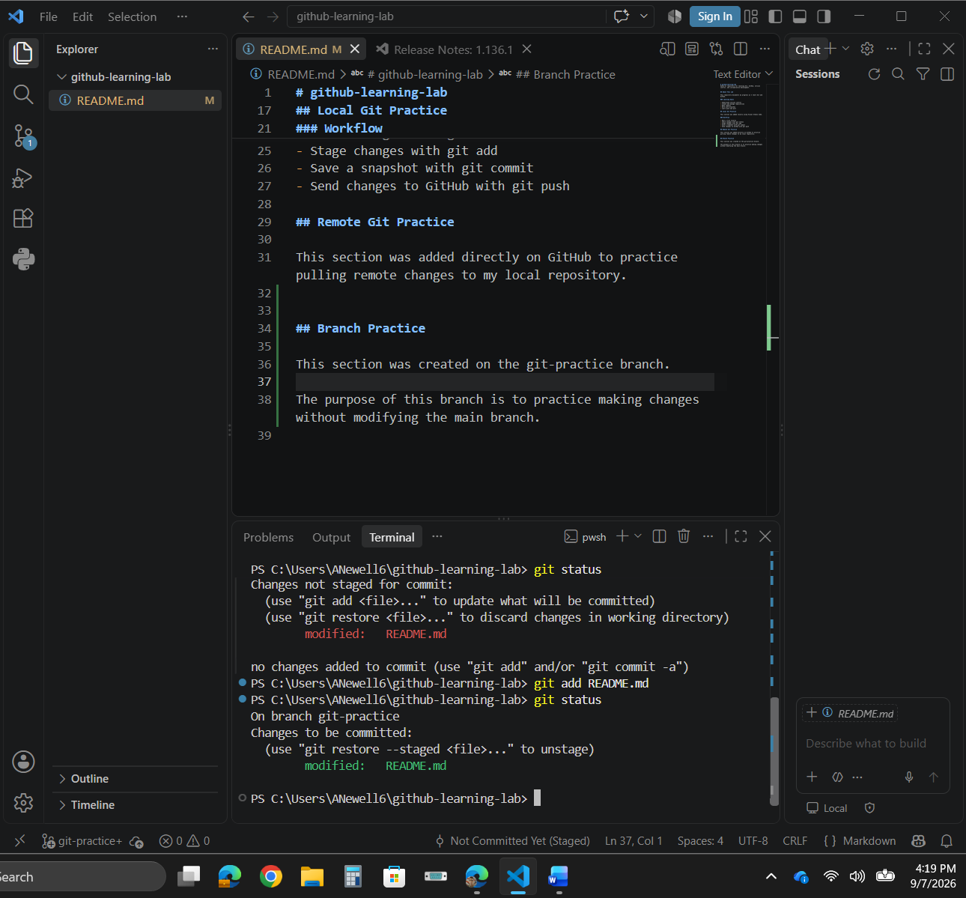
Run:  git commit -m "Add branch practice section"  git commit -m "Add branch practice section"  │ │ │ │  │ │ │ └── Description of the checkpoint  │ │ │  │ │ └────────────────── -m = provide a commit message  │ │  │ └───────────────────────── Create a commit from staged changes  │  └────────────────────────────── Run Git | 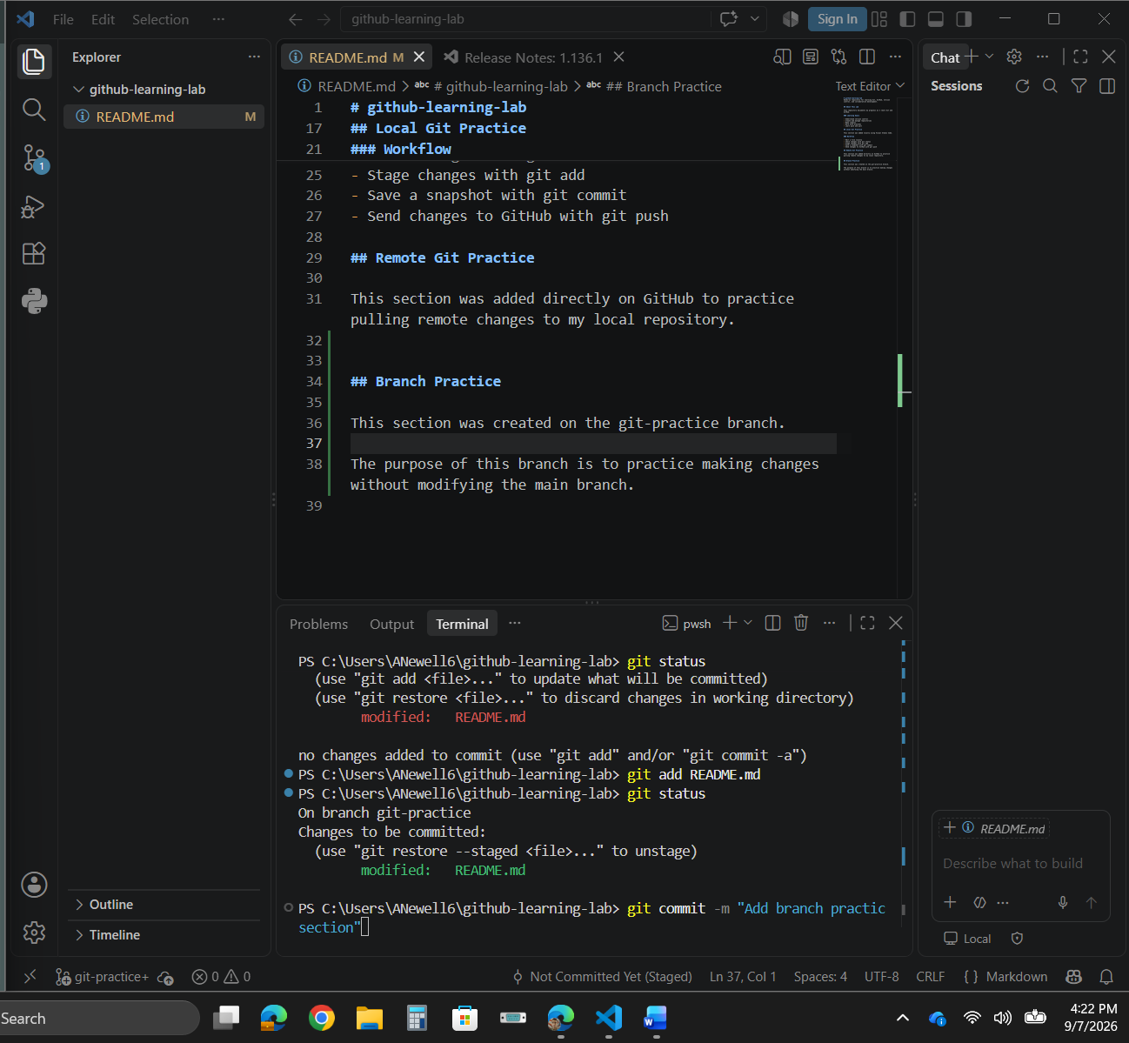
Run:  git commit -m "Add branch practice section" | 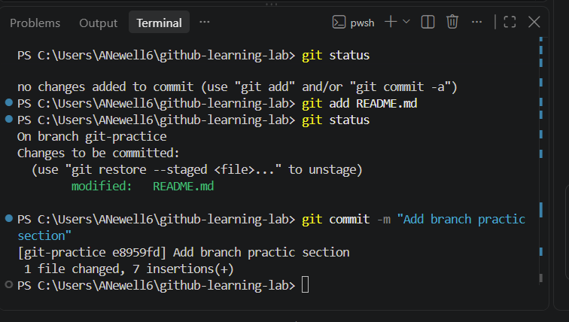
Next Run:  git log --oneline --all --decorate -6  git log  │  └── View commit history  --oneline  └── Condense each commit to one line  --all  └── Include commits reachable from all refs  --decorate  └── Display reference names such as HEAD,  branches, and remote-tracking branches  -6  └── Limit output to six commits | 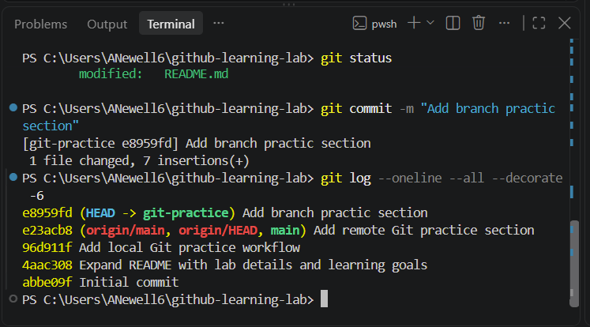
A typo was identified in the most recent commit message. Because the commit had not yet been pushed to the remote repository, git commit --amend was used to replace the most recent commit with a corrected version. | Correcting the Most Recent Commit with --amend
*Notice I had messed up on a:  e8959fd “Add branch practic section”  in order to change it we must use the –amend with git commit. | 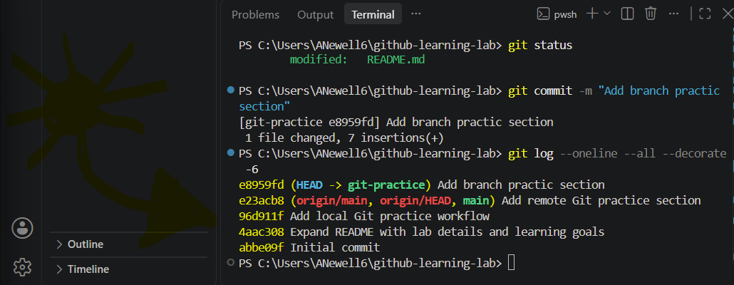
Run:  git commit --amend -m "Add branch practice section"  git commit --amend -m "Add branch practice section"  │ │ │ │ │  │ │ │ │ └── Corrected commit message  │ │ │ │  │ │ │ └───── Supply a message directly  │ │ │  │ │ └──────────── Modify the most recent commit  │ │  │ └───────────────────── Work with a commit  │  └───────────────────────── Git | 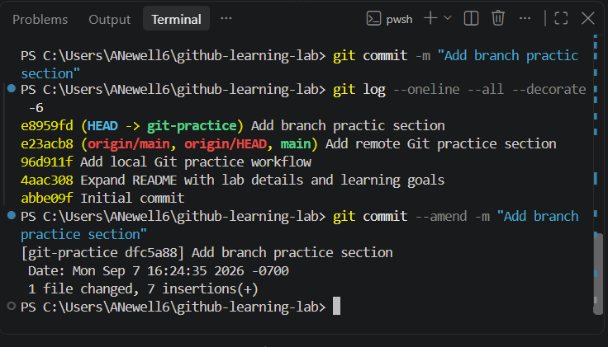
 | Pushing the Branch to GitHub
Run:  git push -u origin git-practice  git push -u origin git-practice  │ │ │ │  │ │ │ └── Branch we want to send  │ │ │ to GitHub  │ │ │  │ │ └──────── Remote repository name  │ │ origin = the name of the remote that points to our GitHub repository.  │ │  │ └───────────── Set the upstream tracking relationship  │ between local git-practice and  │ origin/git-practice  │  └────────────────── Run Git | git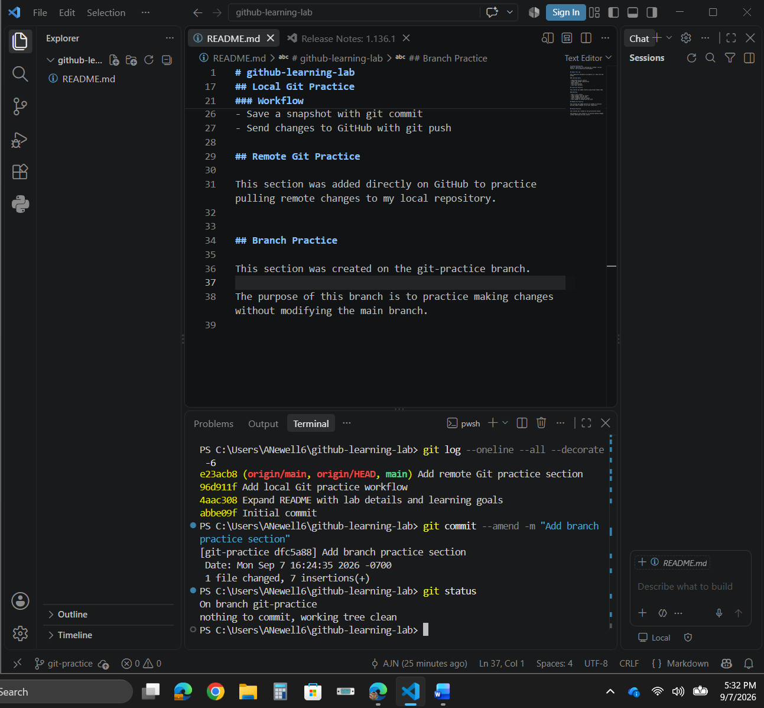
 | 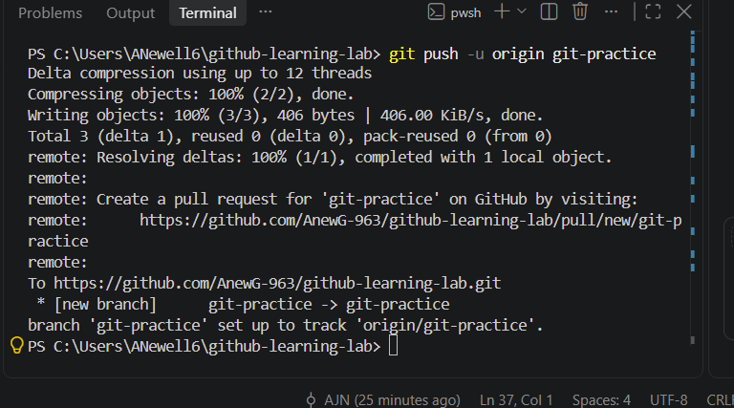
 | Comparing main and git-practice
Run:  git diff main..git-practice  git diff main..git-practice  │ │ │ │  │ │ │ └── Compare against git-practice  │ │ │  │ │ └────────── Starting branch: main  │ │  │ └──────────────── Show differences  │  └──────────────────── Run Git | 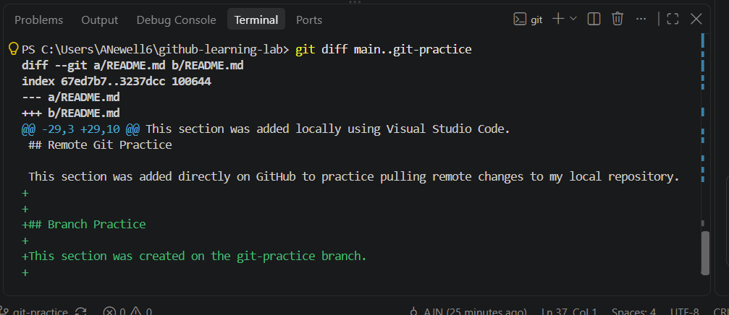
A Pull Request is basically:  “I have changes on git-practice. Please review them before bringing them into main.” | Create first Pull Request
On GitHub, open your github-learning-lab repository. GitHub will often show a banner like:  git-practice had recent pushes  Compare & pull request  If you see ‘Compare & pull request’, click it. | 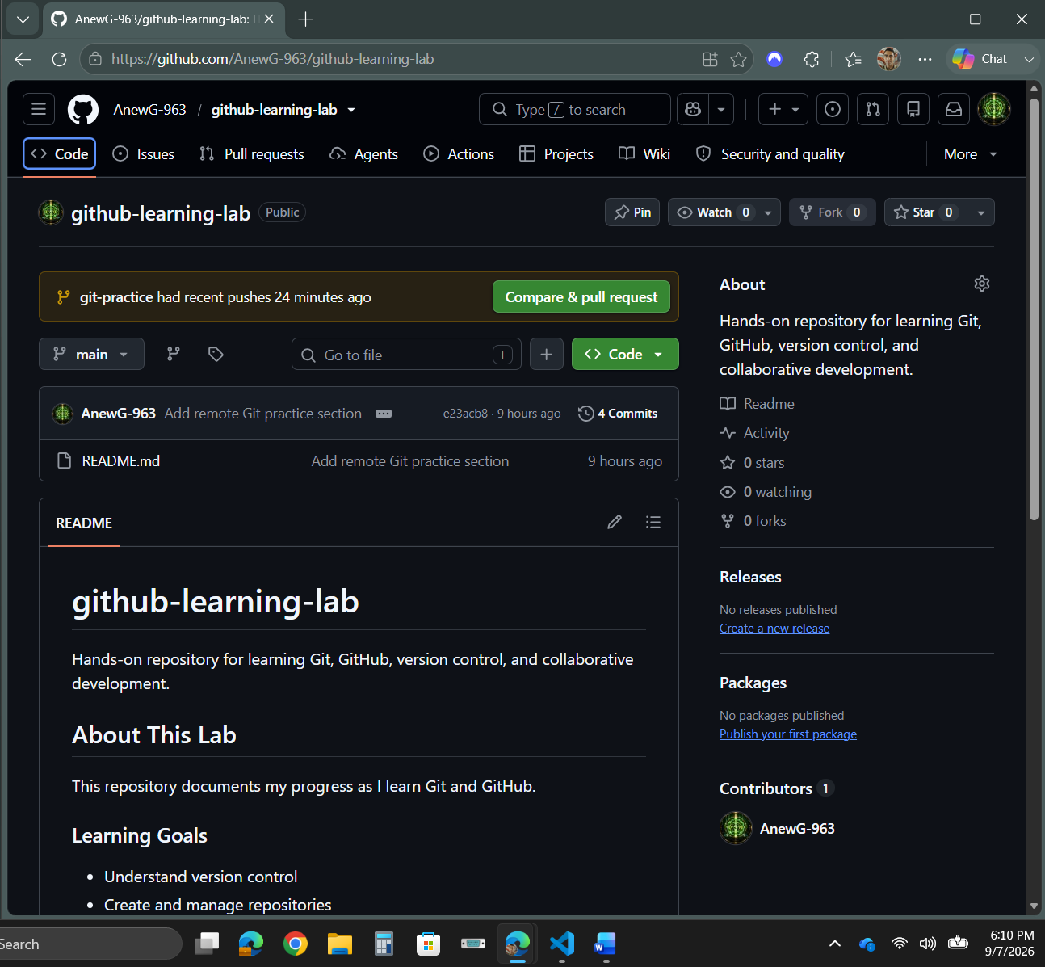
## Summary  Adds a Branch Practice section to the README as part of the Git branching lab.  ## Changes  - Created and worked from the `git-practice` branch.  - Added documentation explaining the purpose of the practice branch.  - Preserved the existing `main` branch while developing the change separately.  ## Purpose  This change demonstrates the Git branch workflow and prepares the branch to be merged into `main`. | 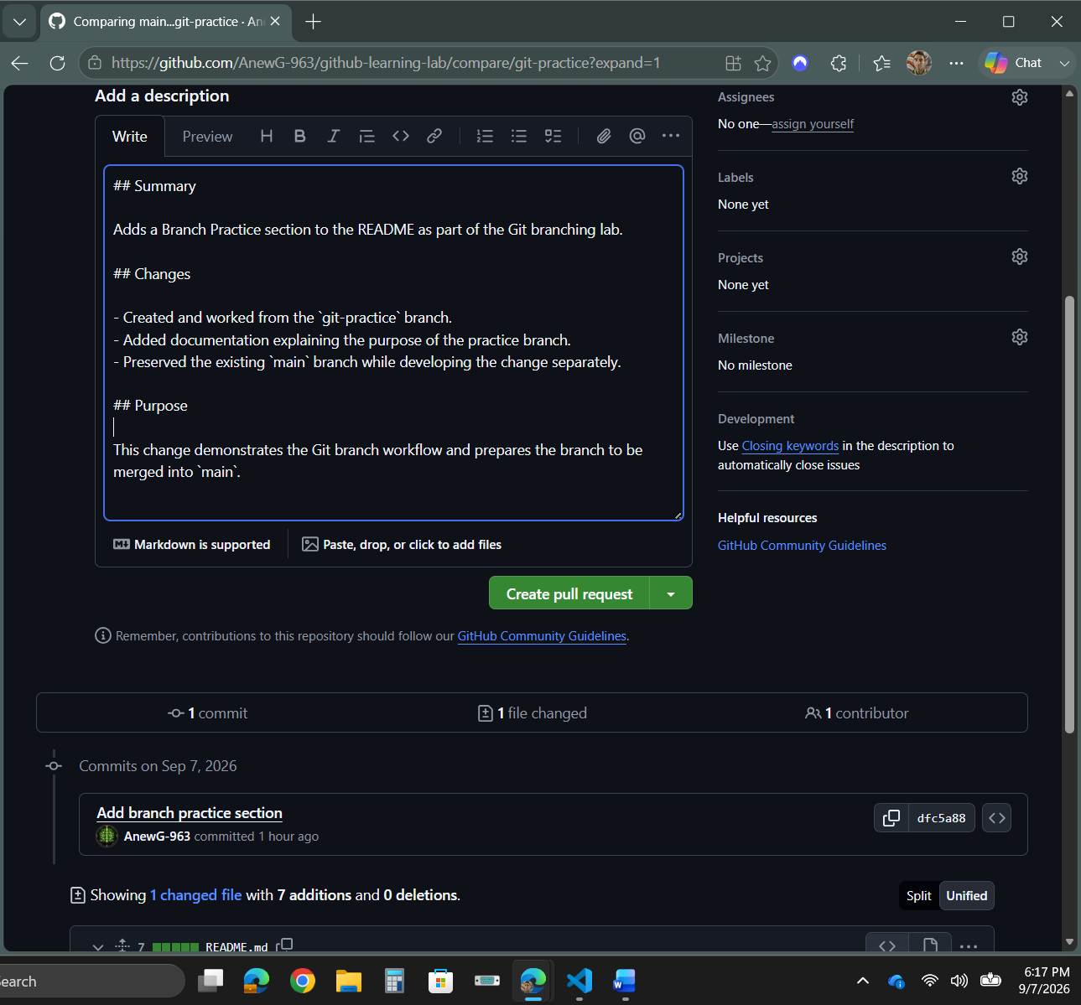
Next:  Go to and CLICK ‘Conversation’. | 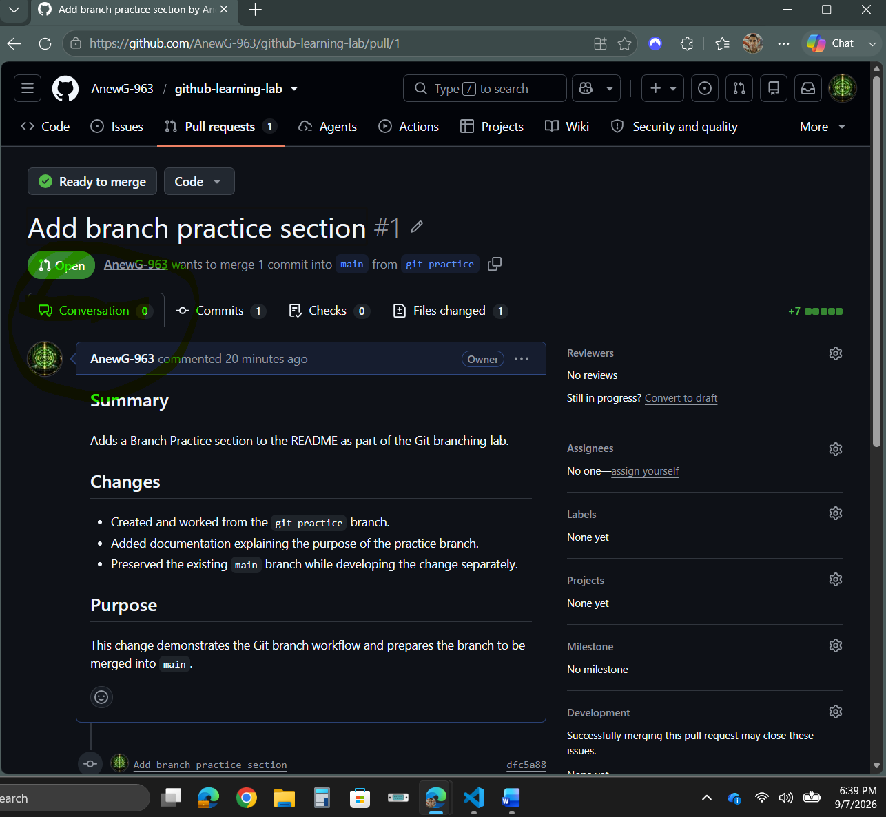
Next  Scroll down to ‘Commit merge’ and merge your branch to main. | 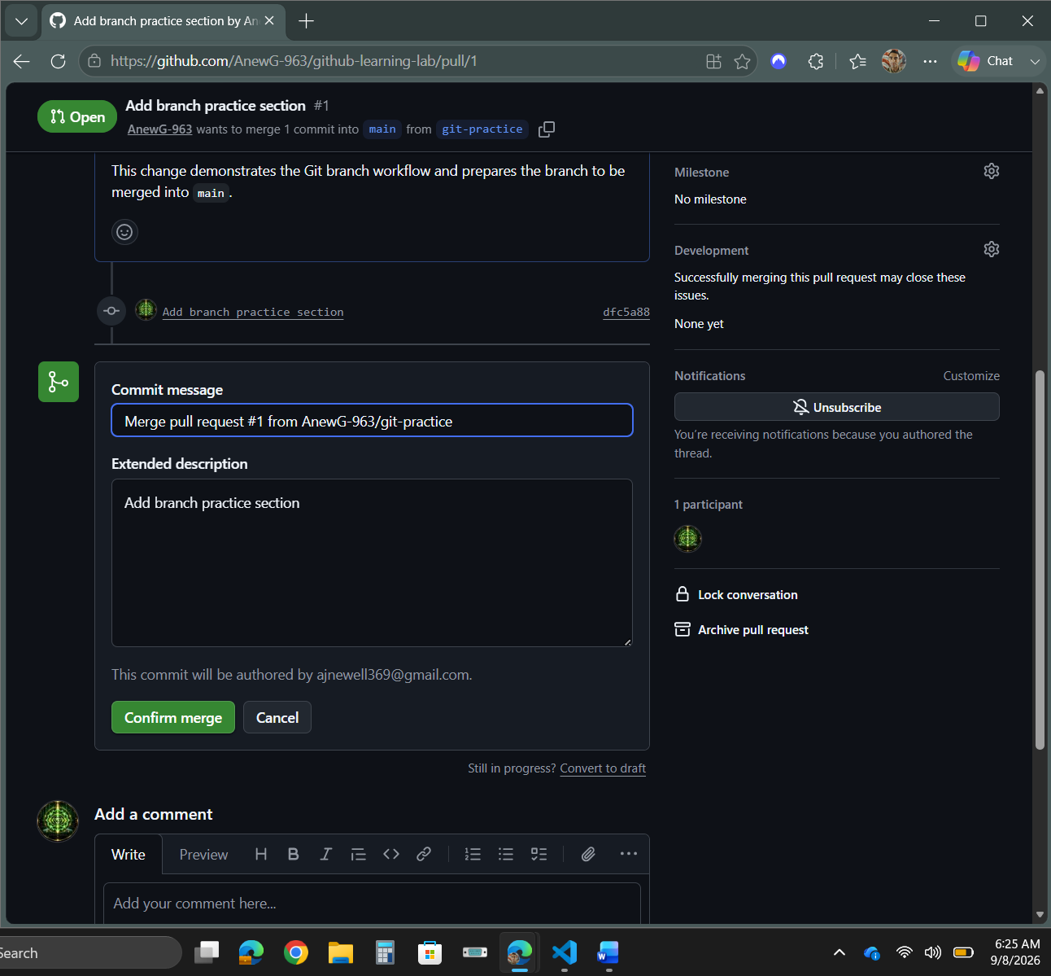
Merge should be successful. | 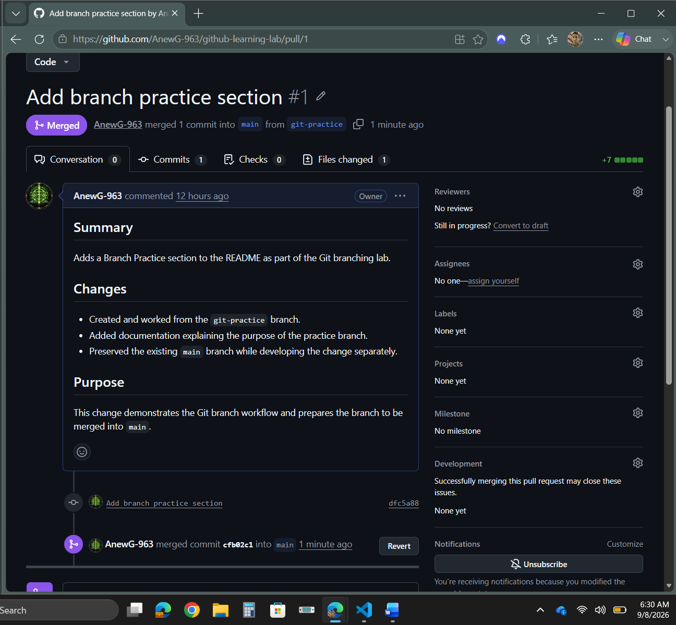
Run:  git diff main..git-practice  Run :  git switch main  Run :  git status  Run :  git fetch  Run :  git status  Run :  git pull | 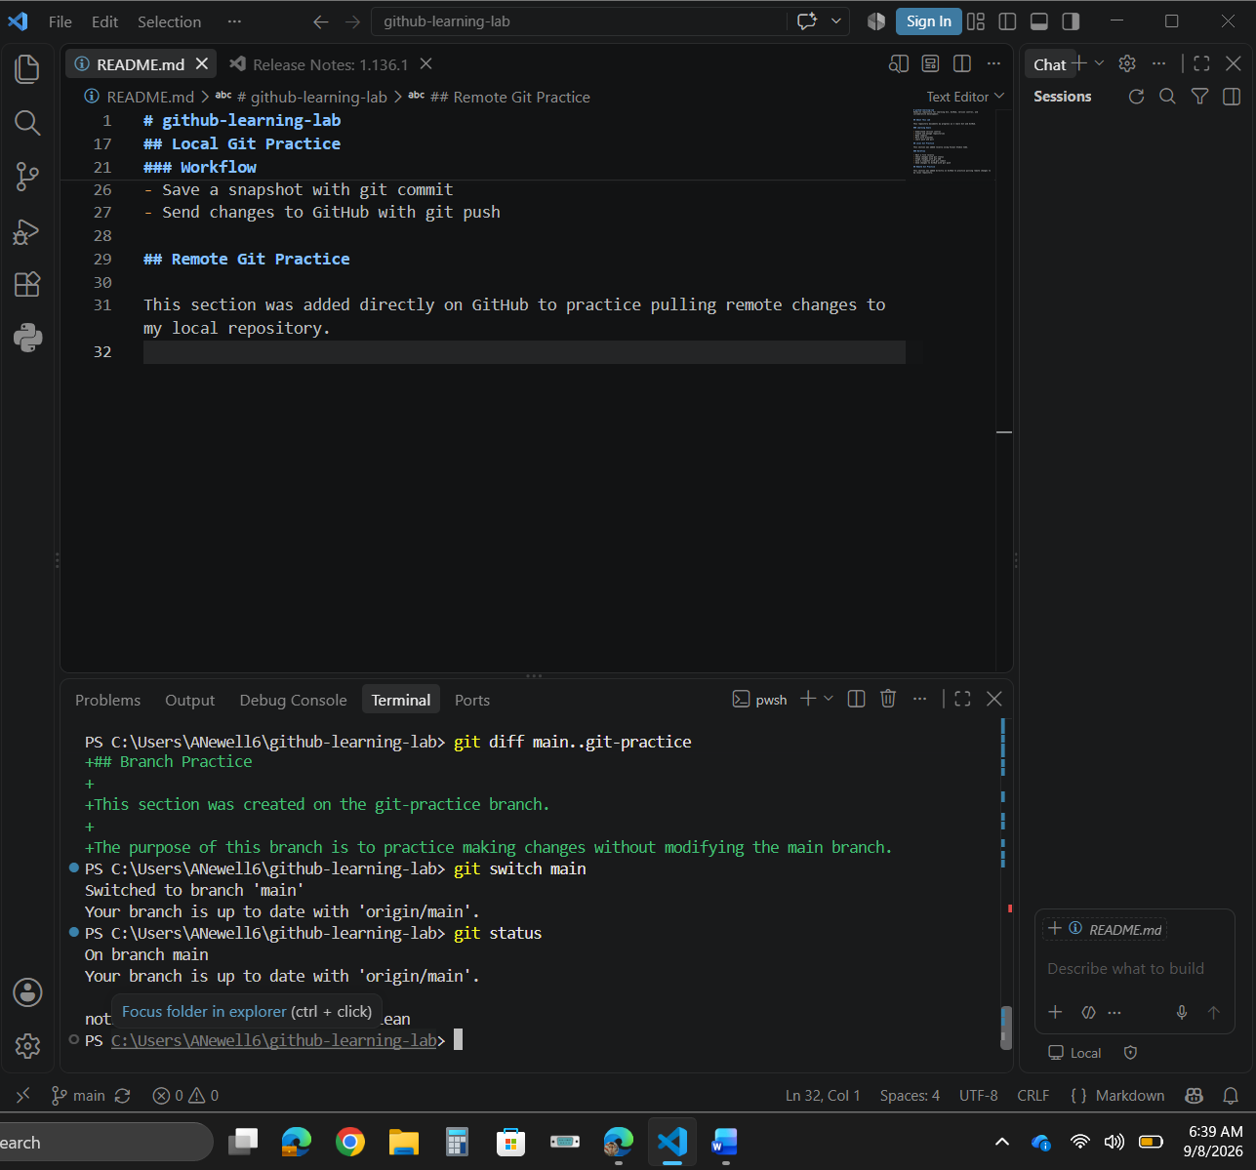
 | Verifying with ‘git pull’
Run:  git pull  git pull  │ │  │ └── Retrieve remote changes AND integrate them  │ into the branch I'm currently on  │  └────── Git | 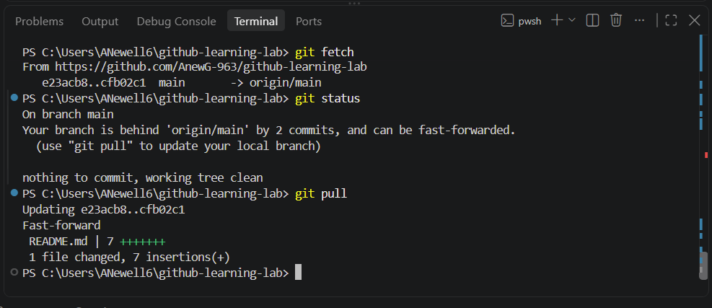
 | Overall Objectives
Git Branching Lab
│
├── 1. Creating the git-practice Branch
│
├── 2. Understanding HEAD
│
├── 3. Switching Between Branches
│
├── 4. Modifying README.md
│
├── 5. Checking Changes with git status
│
├── 6. Staging with git add
│
├── 7. Creating a Commit
│
├── 8. Viewing Commit History
│
├── 9. Correcting a Commit with --amend
│
├── 10. Pushing the Branch to GitHub
│
├── 11. Comparing main and git-practice
│
├── 12. Creating a Pull Request
│
└── 13. Merging git-practice into main

